<https://www.javatpoint.com/computer-network-introduction>

What is a Computer Network?

* **Computer Network** is a group of computers connected with each other through wires, optical fibres or optical links so that various devices can interact with each other through a network.
* The aim of the computer network is the sharing of resources among various devices.
* In the case of computer network technology, there are several types of networks that vary from simple to complex level.

Components Of Computer Network:

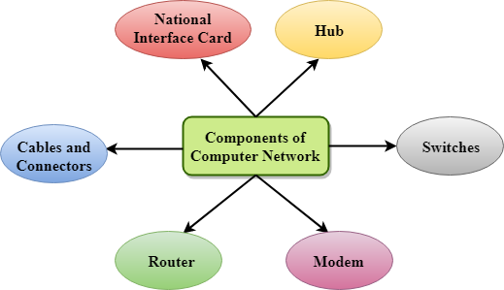

Major components of a computer network are:

NIC(National interface card)

NIC is a device that helps the computer to communicate with another device. The network interface card contains the hardware addresses, the data-link layer protocol use this address to identify the system on the network so that it transfers the data to the correct destination.

There are two types of NIC: wireless NIC and wired NIC.

* **Wireless NIC:** All the modern laptops use the wireless NIC. In Wireless NIC, a connection is made using the antenna that employs the **radio wave technology**.
* **Wired NIC:** Cables use the **wired NIC** to transfer the data over the medium.

Hub

Hub is a central device that splits the network connection into multiple devices. When computer requests for information from a computer, it sends the request to the Hub. Hub distributes this request to all the interconnected computers.

Switches

Switch is a networking device that groups all the devices over the network to transfer the data to another device. A switch is better than Hub as it does not broadcast the message over the network, i.e., it sends the message to the device for which it belongs to. Therefore, we can say that switch sends the message directly from source to the destination.

Cables and connectors

Cable is a transmission media that transmits the communication signals. **There are three types of cables:**

* **Twisted pair cable:** It is a high-speed cable that transmits the data over **1Gbps** or more.
* **Coaxial cable:** Coaxial cable resembles like a TV installation cable. Coaxial cable is more expensive than twisted pair cable, but it provides the high data transmission speed.
* **Fibre optic cable:** Fibre optic cable is a high-speed cable that transmits the data using light beams. It provides high data transmission speed as compared to other cables. It is more expensive as compared to other cables, so it is installed at the government level.

Router

Router is a device that connects the LAN to the internet. The router is mainly used to connect the distinct networks or connect the internet to multiple computers.

Modem

Modem connects the computer to the internet over the existing telephone line. A modem is not integrated with the computer motherboard. A modem is a separate part on the PC slot found on the motherboard.

Uses of Computer Network

* **Resource sharing:** Resource sharing is the sharing of resources such as programs, printers, and data among the users on the network without the requirement of the physical location of the resource and user.
* **Server-Client model:** Computer networking is used in the **server-client model**. A server is a central computer used to store the information and maintained by the system administrator. Clients are the machines used to access the information stored in the server remotely.
* **Communication medium:** Computer network behaves as a communication medium among the users. For example, a company contains more than one computer has an email system which the employees use for daily communication.
* **E-commerce:** Computer network is also important in businesses. We can do the business over the internet. For example, amazon.com is doing their business over the internet, i.e., they are doing their business over the internet.

Features Of Computer network

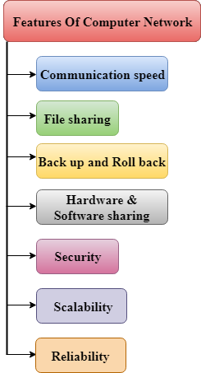

A list Of Computer network features is given below.

* Communication speed
* File sharing
* Back up and Roll back is easy
* Software and Hardware sharing
* Security
* Scalability
* Reliability

Communication speed

Network provides us to communicate over the network in a fast and efficient manner. For example, we can do video conferencing, email messaging, etc. over the internet. Therefore, the computer network is a great way to share our knowledge and ideas.

File sharing

File sharing is one of the major advantage of the computer network. Computer network provides us to share the files with each other.

Back up and Roll back is easy

Since the files are stored in the main server which is centrally located. Therefore, it is easy to take the back up from the main server.

Software and Hardware sharing

We can install the applications on the main server, therefore, the user can access the applications centrally. So, we do not need to install the software on every machine. Similarly, hardware can also be shared.

Security

Network allows the security by ensuring that the user has the right to access the certain files and applications.

Scalability

Scalability means that we can add the new components on the network. Network must be scalable so that we can extend the network by adding new devices. But, it decreases the speed of the connection and data of the transmission speed also decreases, this increases the chances of error occurring. This problem can be overcome by using the routing or switching devices.

Reliability

Computer network can use the alternative source for the data communication in case of any hardware failure.

Computer Network Architecture

Computer Network Architecture is defined as the physical and logical design of the software, hardware, protocols, and media of the transmission of data. Simply we can say that how computers are organized and how tasks are allocated to the computer.

**The two types of network architectures are used:**

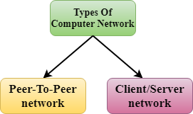

* Peer-To-Peer network
* Client/Server network

Peer-To-Peer network

* Peer-To-Peer network is a network in which all the computers are linked together with equal privilege and responsibilities for processing the data.
* Peer-To-Peer network is useful for small environments, usually up to 10 computers.
* Peer-To-Peer network has no dedicated server.
* Special permissions are assigned to each computer for sharing the resources, but this can lead to a problem if the computer with the resource is down.

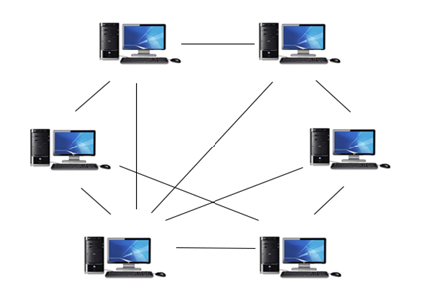

Advantages Of Peer-To-Peer Network:

* It is less costly as it does not contain any dedicated server.
* If one computer stops working but, other computers will not stop working.
* It is easy to set up and maintain as each computer manages itself.

Disadvantages Of Peer-To-Peer Network:

* In the case of Peer-To-Peer network, it does not contain the centralized system . Therefore, it cannot back up the data as the data is different in different locations.
* It has a security issue as the device is managed itself.

Client/Server Network

* Client/Server network is a network model designed for the end users called clients, to access the resources such as songs, video, etc. from a central computer known as Server.
* The central controller is known as a **server** while all other computers in the network are called **clients**.
* A server performs all the major operations such as security and network management.
* A server is responsible for managing all the resources such as files, directories, printer, etc.
* All the clients communicate with each other through a server. For example, if client1 wants to send some data to client 2, then it first sends the request to the server for the permission. The server sends the response to the client 1 to initiate its communication with the client 2.

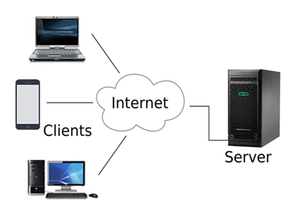

Advantages Of Client/Server network:

* A Client/Server network contains the centralized system. Therefore we can back up the data easily.
* A Client/Server network has a dedicated server that improves the overall performance of the whole system.
* Security is better in Client/Server network as a single server administers the shared resources.
* It also increases the speed of the sharing resources.

Disadvantages of Client/Server network:

* Client/Server network is expensive as it requires the server with large memory.
* A server has a Network Operating System (NOS) to provide the resources to the clients, but the cost of NOS is very high.
* It requires a dedicated network administrator to manage all the resources.

Computer Network Types

A computer network is a group of computers linked to each other that enables the computer to communicate with another computer and share their resources, data, and applications.

A computer network can be categorized by their size. A **computer network** is mainly of **four types**:

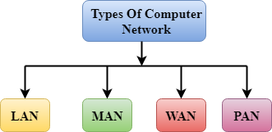

* LAN(Local Area Network)
* PAN(Personal Area Network)
* MAN(Metropolitan Area Network)
* WAN(Wide Area Network)

LAN(Local Area Network)

* Local Area Network is a group of computers connected to each other in a small area such as building, office.
* LAN is used for connecting two or more personal computers through a communication medium such as twisted pair, coaxial cable, etc.
* It is less costly as it is built with inexpensive hardware such as hubs, network adapters, and ethernet cables.
* The data is transferred at an extremely faster rate in Local Area Network.
* Local Area Network provides higher security.

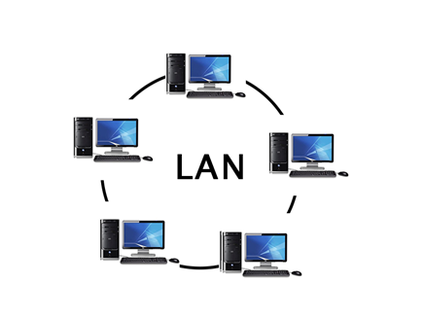

PAN(Personal Area Network)

* Personal Area Network is a network arranged within an individual person, typically within a range of 10 meters.
* Personal Area Network is used for connecting the computer devices of personal use is known as Personal Area Network.
* **Thomas Zimmerman** was the first research scientist to bring the idea of the Personal Area Network.
* Personal Area Network covers an area of **30 feet**.
* Personal computer devices that are used to develop the personal area network are the laptop, mobile phones, media player and play stations.

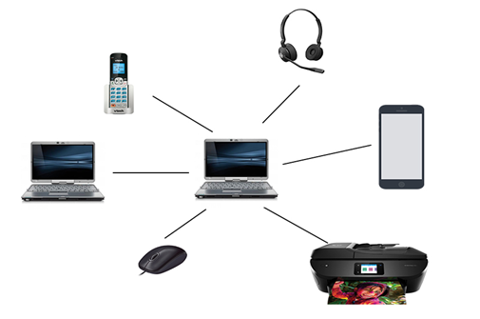

**There are two types of Personal Area Network:**

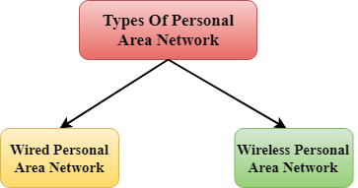

* Wired Personal Area Network
* Wireless Personal Area Network

**Wireless Personal Area Network:** Wireless Personal Area Network is developed by simply using wireless technologies such as WiFi, Bluetooth. It is a low range network.

**Wired Personal Area Network:** Wired Personal Area Network is created by using the USB.

Examples Of Personal Area Network:

* **Body Area Network:** Body Area Network is a network that moves with a person. **For example**, a mobile network moves with a person. Suppose a person establishes a network connection and then creates a connection with another device to share the information.
* **Offline Network:** An offline network can be created inside the home, so it is also known as a **home network**. A home network is designed to integrate the devices such as printers, computer, television but they are not connected to the internet.
* **Small Home Office:** It is used to connect a variety of devices to the internet and to a corporate network using a VPN

MAN(Metropolitan Area Network)

* A metropolitan area network is a network that covers a larger geographic area by interconnecting a different LAN to form a larger network.
* Government agencies use MAN to connect to the citizens and private industries.
* In MAN, various LANs are connected to each other through a telephone exchange line.
* The most widely used protocols in MAN are RS-232, Frame Relay, ATM, ISDN, OC-3, ADSL, etc.
* It has a higher range than Local Area Network(LAN).

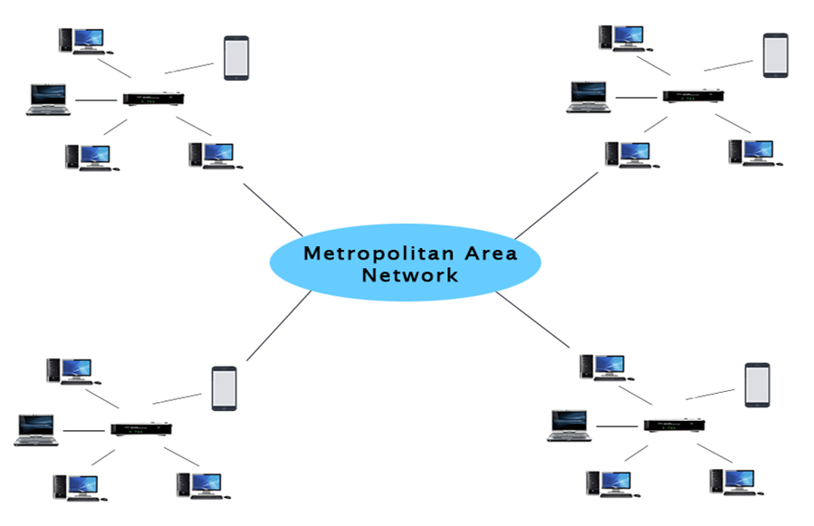

Uses Of Metropolitan Area Network:

* MAN is used in communication between the banks in a city.
* It can be used in an Airline Reservation.
* It can be used in a college within a city.
* It can also be used for communication in the military.

WAN(Wide Area Network)

* A Wide Area Network is a network that extends over a large geographical area such as states or countries.
* A Wide Area Network is quite bigger network than the LAN.
* A Wide Area Network is not limited to a single location, but it spans over a large geographical area through a telephone line, fibre optic cable or satellite links.
* The internet is one of the biggest WAN in the world.
* A Wide Area Network is widely used in the field of Business, government, and education.

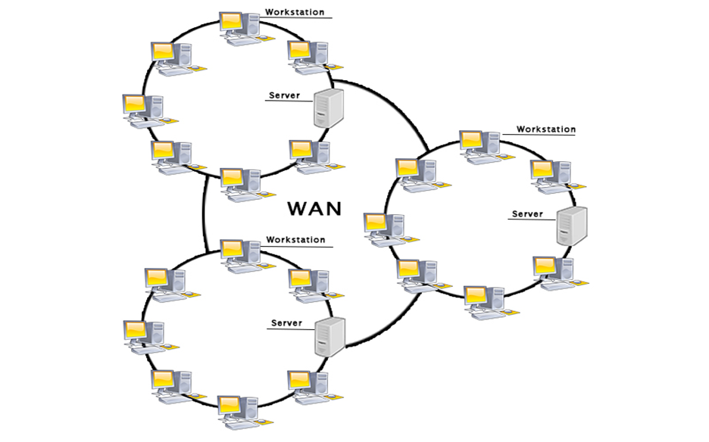

Examples Of Wide Area Network:

* **Mobile Broadband:** A 4G network is widely used across a region or country.
* **Last mile:** A telecom company is used to provide the internet services to the customers in hundreds of cities by connecting their home with fiber.
* **Private network:** A bank provides a private network that connects the 44 offices. This network is made by using the telephone leased line provided by the telecom company.

Advantages Of Wide Area Network:

Following are the advantages of the Wide Area Network:

* **Geographical area:** A Wide Area Network provides a large geographical area. Suppose if the branch of our office is in a different city then we can connect with them through WAN. The internet provides a leased line through which we can connect with another branch.
* **Centralized data:** In case of WAN network, data is centralized. Therefore, we do not need to buy the emails, files or back up servers.
* **Get updated files:** Software companies work on the live server. Therefore, the programmers get the updated files within seconds.
* **Exchange messages:** In a WAN network, messages are transmitted fast. The web application like Facebook, Whatsapp, Skype allows you to communicate with friends.
* **Sharing of software and resources:** In WAN network, we can share the software and other resources like a hard drive, RAM.
* **Global business:** We can do the business over the internet globally.
* **High bandwidth:** If we use the leased lines for our company then this gives the high bandwidth. The high bandwidth increases the data transfer rate which in turn increases the productivity of our company.

Disadvantages of Wide Area Network:

The following are the disadvantages of the Wide Area Network:

* **Security issue:** A WAN network has more security issues as compared to LAN and MAN network as all the technologies are combined together that creates the security problem.
* **Needs Firewall & antivirus software:** The data is transferred on the internet which can be changed or hacked by the hackers, so the firewall needs to be used. Some people can inject the virus in our system so antivirus is needed to protect from such a virus.
* **High Setup cost:** An installation cost of the WAN network is high as it involves the purchasing of routers, switches.
* **Troubleshooting problems:** It covers a large area so fixing the problem is difficult.

**The OSI Reference Model**

OSI or Open System Interconnection model was developed by International Standards Organization (ISO). It gives a layered networking framework that conceptualizes how communications should be done between heterogeneous systems. It has seven interconnected layers. The seven layers of the OSI Model are a physical layer, data link layer, network layer, transport layer, session layer, presentation layer, and application layer, as shown in the following diagram −

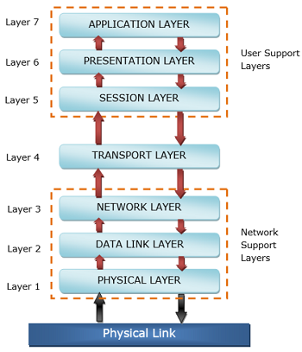

The physical layer, data link layer and the network layer are the network support layers. The layers manage a physical transfer of data from one device to another. Session layer, presentation layer, and application layer are the user support layers. These layers allow communication among unrelated software in dissimilar environments. Transport layer links the two groups.

The main functions of each of the layers are as follows −

* **Physical Layer −** Its function is to transmit individual bits from one node to another over a physical medium.
* **Data Link Layer −** It is responsible for the reliable transfer of data frames from one node to another connected by the physical layer.
* **Network Layer −** It manages the delivery of individual data packets from source to destination through appropriate addressing and routing.
* **Transport Layer −**It is responsible for delivery of the entire message from the source host to destination host.
* **Session Layer −** It establishes sessions between users and offers services like dialog control and synchronization.
* **Presentation Layer −** It monitors syntax and semantics of transmitted information through translation, compression, and encryption.
* **Application Layer −** It provides high-level APIs (application program interface) to the users.

OSI stands for **Open Systems Interconnection**. It has been developed by ISO – ‘**International Organization for Standardization**‘, in the year 1984. It is a 7 layer architecture with each layer having specific functionality to perform. All these 7 layers work collaboratively to transmit the data from one person to another across the globe.

### ****1. Physical Layer (Layer 1):****

The lowest layer of the OSI reference model is the physical layer. It is responsible for the actual physical connection between the devices. The physical layer contains information in the form of**bits.** It is responsible for transmitting individual bits from one node to the next. When receiving data, this layer will get the signal received and convert it into 0s and 1s and send them to the Data Link layer, which will put the frame back together.

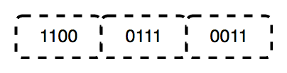

The functions of the physical layer are as follows:

1. **Bit synchronization:** The physical layer provides the synchronization of the bits by providing a clock. This clock controls both sender and receiver thus providing synchronization at bit level.
2. **Bit rate control:** The Physical layer also defines the transmission rate i.e. the number of bits sent per second.
3. **Physical topologies:** Physical layer specifies the way in which the different, devices/nodes are arranged in a network i.e. bus, star, or mesh topology.
4. **Transmission mode:** Physical layer also defines the way in which the data flows between the two connected devices. The various transmission modes possible are Simplex, half-duplex and full-duplex.

* Hub, Repeater, Modem, Cables are Physical Layer devices.

** Network Layer, Data Link Layer, and Physical Layer are also known as **Lower Layers** or **Hardware Layers**.

### ****2. Data Link Layer (DLL) (Layer 2):****

The data link layer is responsible for the node-to-node delivery of the message. The main function of this layer is to make sure data transfer is error-free from one node to another, over the physical layer. When a packet arrives in a network, it is the responsibility of DLL to transmit it to the Host using its MAC address.   
Data Link Layer is divided into two sublayers:

1. Logical Link Control (LLC)
2. Media Access Control (MAC)

The packet received from the Network layer is further divided into frames depending on the frame size of NIC (Network Interface Card). DLL also encapsulates Sender and Receiver’s MAC address in the header.

The Receiver’s MAC address is obtained by placing an ARP(Address Resolution Protocol) request onto the wire asking “Who has that IP address?” and the destination host will reply with its MAC address.

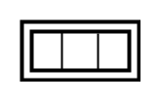

The functions of the Data Link layer are:

1. **Framing:**Framing is a function of the data link layer. It provides a way for a sender to transmit a set of bits that are meaningful to the receiver. This can be accomplished by attaching special bit patterns to the beginning and end of the frame.
2. **Physical addressing:** After creating frames, the Data link layer adds physical addresses (MAC address) of the sender and/or receiver in the header of each frame.
3. **Error control:** Data link layer provides the mechanism of error control in which it detects and retransmits damaged or lost frames.
4. **Flow Control:** The data rate must be constant on both sides else the data may get corrupted thus, flow control coordinates the amount of data that can be sent before receiving acknowledgement.
5. **Access control:**When a single communication channel is shared by multiple devices, the MAC sub-layer of the data link layer helps to determine which device has control over the channel at a given time.

*\* Packet in Data Link layer is referred to as* ***Frame.***

** Data Link layer is handled by the NIC (Network Interface Card) and device drivers of host machines.

*** Switch & Bridge are Data Link Layer devices.

### ****3. Network Layer (Layer 3):****

The network layer works for the transmission of data from one host to the other located in different networks. It also takes care of packet routing i.e. selection of the shortest path to transmit the packet, from the number of routes available. The sender & receiver’s IP addresses are placed in the header by the network layer.

The functions of the Network layer are:

1. **Routing:** The network layer protocols determine which route is suitable from source to destination. This function of the network layer is known as routing.
2. **Logical Addressing:**In order to identify each device on internetwork uniquely, the network layer defines an addressing scheme. The sender & receiver’s IP addresses are placed in the header by the network layer. Such an address distinguishes each device uniquely and universally.

*\* Segment* in Network layer is referred to as **Packet**.



** Network layer is implemented by networking devices such as routers.

### ****4. Transport Layer (Layer 4):****

The transport layer provides services to the application layer and takes services from the network layer. The data in the transport layer is referred to as *Segments*. It is responsible for the End to End Delivery of the complete message. The transport layer also provides the acknowledgement of the successful data transmission and re-transmits the data if an error is found.

**At sender’s side:**Transport layer receives the formatted data from the upper layers, performs **Segmentation**, and also implements **Flow & Error control** to ensure proper data transmission. It also adds Source and Destination port numbers in its header and forwards the segmented data to the Network Layer.

***Note:****The sender needs to know the port number associated with the receiver’s application.*

Generally, this destination port number is configured, either by default or manually. For example, when a web application makes a request to a web server, it typically uses port number 80, because this is the default port assigned to web applications. Many applications have default ports assigned.

**At receiver’s side:** Transport Layer reads the port number from its header and forwards the Data which it has received to the respective application. It also performs sequencing and reassembling of the segmented data.

The functions of the transport layer are as follows:

1. **Segmentation and Reassembly:** This layer accepts the message from the (session) layer, and breaks the message into smaller units. Each of the segments produced has a header associated with it. The transport layer at the destination station reassembles the message.
2. **Service Point Addressing:** In order to deliver the message to the correct process, the transport layer header includes a type of address called service point address or port address. Thus by specifying this address, the transport layer makes sure that the message is delivered to the correct process.

The services provided by the transport layer:

**A. Connection-Oriented Service:** It is a three-phase process that includes

– Connection Establishment   
– Data Transfer   
– Termination / disconnection

In this type of transmission, the receiving device sends an acknowledgement, back to the source after a packet or group of packets is received. This type of transmission is reliable and secure.

**B. Connectionless service:** It is a one-phase process and includes Data Transfer. In this type of transmission, the receiver does not acknowledge receipt of a packet. This approach allows for much faster communication between devices. Connection-oriented service is more reliable than connectionless Service.

*\* Data in the Transport Layer is called as****Segments****.*  
*\*\* Transport layer is operated by the Operating System. It is a part of the OS and communicates with the Application Layer by making system calls.*  
*Transport Layer is called as****Heart of OSI****model.*

### ****5. Session Layer (Layer 5):****

This layer is responsible for the establishment of connection, maintenance of sessions, authentication, and also ensures security.   
The functions of the session layer are:

1. **Session establishment, maintenance, and termination:** The layer allows the two processes to establish, use and terminate a connection.
2. **Synchronization:** This layer allows a process to add checkpoints which are considered synchronization points into the data. These synchronization points help to identify the error so that the data is re-synchronized properly, and ends of the messages are not cut prematurely and data loss is avoided.
3. **Dialog Controller:** The session layer allows two systems to start communication with each other in half-duplex or full-duplex.

*\*\*All the below 3 layers (including Session Layer) are integrated as a single layer in the TCP/IP model as “Application Layer”.*  
*\*\*Implementation of these 3 layers is done by the network application itself. These are also known as****Upper Layers****or****Software Layers****.*

### Scenario:

Let us consider a scenario where a user wants to send a message through some Messenger application running in his browser. The “Messenger” here acts as the application layer which provides the user with an interface to create the data. This message or so-called Data is compressed, encrypted (if any secure data), and converted into bits (0’s and 1’s) so that it can be transmitted.

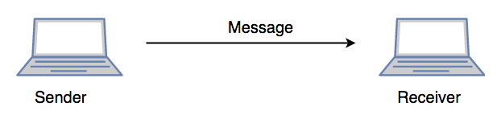

### ****6. Presentation Layer (Layer 6):****

The presentation layer is also called the **Translation layer**. The data from the application layer is extracted here and manipulated as per the required format to transmit over the network.   
The functions of the presentation layer are:

* **Translation:** For example, ASCII to EBCDIC.
* **Encryption/ Decryption:** Data encryption translates the data into another form or code. The encrypted data is known as the ciphertext and the decrypted data is known as plain text. A key value is used for encrypting as well as decrypting data.
* **Compression:** Reduces the number of bits that need to be transmitted on the network.

### ****7. Application Layer (Layer 7):****

At the very top of the OSI Reference Model stack of layers, we find the Application layer which is implemented by the network applications. These applications produce the data, which has to be transferred over the network. This layer also serves as a window for the application services to access the network and for displaying the received information to the user.

Example: Application – Browsers, Skype Messenger, etc.

*\*\*Application Layer is also called Desktop Layer.*

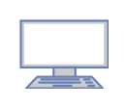

The functions of the Application layer are :

1. Network Virtual Terminal
2. FTAM-File transfer access and management
3. Mail Services
4. Directory Services